**CPRE 288 Final Project Proposal**

**Group Members:** Madison Vosburg, Aydin Sesker, Ryan Hillier, Ritwesh Kumar

**Problem Statement:**

Patients in the hospital and/or nursing homes need critical medications, lab samples, and other medical items delivered. Nursing home staff would make better use of their time not spent on delivering these supplies through crowded hallways around the clock. Medical delivery robots make transporting medicine easy and reduce labor costs and time spent by human workers [2]. This helps staff work more efficiently, thus increasing overall staff productivity. The reliability of these robots will also improve patient outcomes, as they work consistently on time.

**Application Narrative/Story:**

Our project’s goal is to solve a common need found in most communities– the elderly and infirm in nursing homes having easy access to their medicines. By having a robotic lockbox travel from door to door– like a mobile Amazon Locker– nursing home patients will retrieve their medication by entering a code on the bot. The main difference is our bot will have a human operator driving the robot and monitoring the progress of the bot deliveries at all times.

This bot opens up possibilities for both nursing home operators and their residents. Semi-independent residents will get their medicine without relying on staff, as there will only need to be some human operators to drive the bot manually, thereby reducing staffing costs for the home. This technique will also improve residents’ feeling of independence, which has meaningful (but intangible) psychological value. More independent residents will enjoy the convenience of having medicine delivered rather than getting it themselves – this may also reduce staffing costs for the home, as the administrators would be able to automate the distribution process, needing only a handful of human operators driving a bot. As this bot significantly benefits our primary users – nursing homes and their residents – our team believes it has tremendous sales potential.

We will approach this problem by integrating the techniques our team has learned in object avoidance, pathfinding, and local and wireless I/O. Our most significant problem is determining the location of users’ doors. As we cannot use cameras due to project constraints, we will likely have the bot’s operator “know” where it starts and “know” where the doors are without seeing the area directly, and it will update its location with every move. A concern is movement precision – if the bot believes it has moved 500mm but has moved 513mm, this will throw off the bot’s understanding of where it is. Careful calibration will be required, and other ways of improving precision will be explored.

We believe this method of destination-finding is acceptable for our application as the bot’s operator will know what floor the bot is on and does not need to intelligently identify doors, as doors are always in the same place. Object avoidance is our next main concern, as we would like the bot to avoid hitting staff, patients, dropped objects, and other obstacles that may crop up. This can be implemented using our existing techniques, but the object-detection code will need to be updated to ensure the bot knows where it is. We also need to explore how to avoid drops and possibly how to identify spills.

After setting up movement and pathfinding, implementing features like a user interface and PUTTY feedback will be trivial, as we already have experience with these tasks. Note that the “lockbox” part of the bot will not be included as a physical feature, but will instead be visually indicated on PUTTY, the LCD, sound, or with another obvious method of indicating the lockbox would be open.

Lastly, we will try to implement a semi-autonomous method in which humans can drive the bot as it detects and avoids obstacles in its path to the resident’s rooms. The benefit of this technique over a fully autonomous bot is it allows for careful observation of the bot at all times so a human operator can immediately tell if a bot needs to be fixed at a moment’s notice. In the context of aviation, for example, pilots use AI technology to assist them as both humans and computers work together to ensure the safety and efficiency of travel in the air. The same working philosophy will be used in our project to employ man and machine to meet the needs of residents in a nursing home setting.

**Empathy Map:**

In the United States, one-third of prescription drugs are taken by elderly patients, and on average, nursing home patients take seven medications at a time [1]. Taking the correct medication and the right dose at the right time is very important for these patients.

| Do:   * Nursing home patients need to take certain medications [1]   + They need to take certain doses of those meds [1]   + They need to take those meds at certain times [1]   + They need a way of getting those meds delivered to them [1] * Nursing home staff need time to deliver meds [2]   + They would prefer spending more time face-to-face doing patient care [2] * There has been a shortage of professional caregivers in recent years so nursing home staff need ways to be more productive and efficient [3] * Nursing home administrators need better staff productivity, efficiency, ease of using technology, and patient outcomes [2] | Think:   * Nursing home patients:   + “What would happen if I didn’t take my meds?”   + “What if someone can’t deliver my meds to me?”   + “What is a consistent way that I can make sure I take the right meds at the right time?” * Nursing home staff:   + “How can I spend less time in the hallways delivering meds and more time with patients providing care?”   + “How can I work more efficiently and productively to address the shortage of professional caregivers?” * Nursing home administrators:   + “What if I had technology that was easy to use that helped improve staff efficiency and patient outcomes?” |
| --- | --- |
| Say:   * Nursing home patients   + “I wish there was an easy way to get my meds delivered to my door”   + “I need a way to make sure I take the right meds at the right time”   + “I wish I could get my med dosage given consistently and accurately” * Nursing home staff   + “I wish I could spend less time walking in halls transporting meds”   + “I wish I had more time to spend on patient care”   + “How could I work more productively and efficiently to compensate for labor shortages?” * Nursing home administrators   + “I wish I could improve staff and patient experiences and improve staff productivity with easy-to-use technology” | Feel:   * Nursing home patients   + Concerned about what would happen if they can’t get their meds delivered to the right place   + Nervous that they might not get their meds on time   + Scared that they could get the wrong dose * Nursing home staff   + Wishful to spend more time doing patient care   + Overcome by time spent delivering meds   + Overwhelmed by work and lack of help due to labor shortages * Nursing home administrators   + Hoping to find technology that would increase staff productivity and efficiency and boost patient outcomes that are easy-to-use |

**Point-Of-View Statements:**

1. Patients need medicine delivered on time to avoid potential adverse side effects of taking medications late.
2. Patients need the correct medicines delivered to avoid potential adverse side effects of taking incorrect medications.
3. Patients need correct measurement dosages to have the desired effect while not overdosing.
4. Patient staff need to spend less time delivering meds to allow for more time for patient care.
5. Patient staff need ways to work more efficiently and productively to compensate for labor shortages in recent years.
6. Nursing home administrators need easy-to-use technology to improve staff productivity and efficiency and boost patient outcomes.

Final POV Statement:

Patients, staff, and administrators need a medicine delivery robot (MDB) to deliver medications on time with correct dosages to ensure consistent medical treatment, while allowing staff and administration more time to focus on face-to-face patient care and productivity/efficiency within the nursing home.

**Functional Requirements:**

**Lotus Blossom Diagram:**

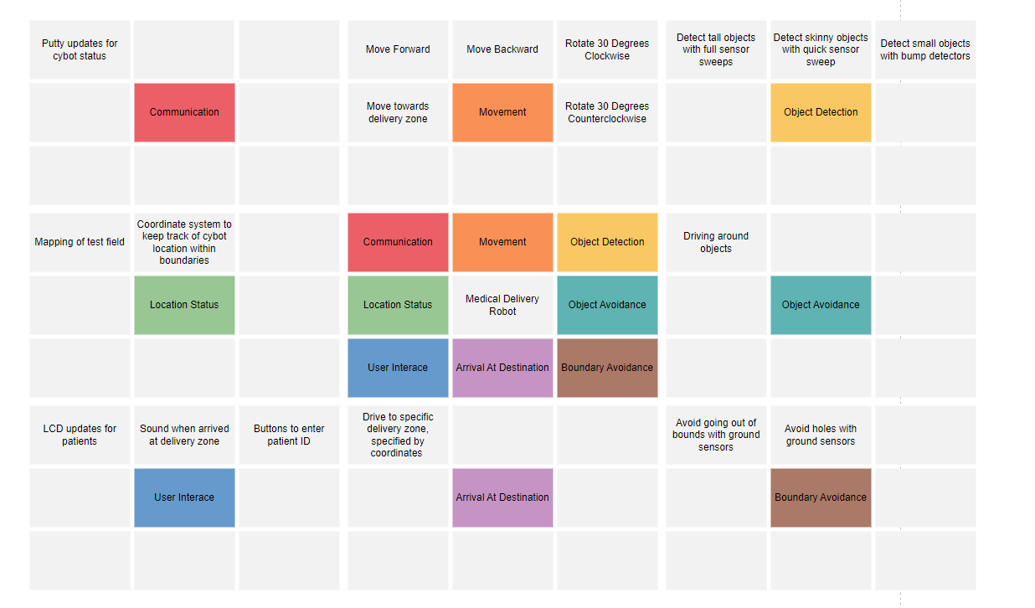

| **Base Functionality** | **Mapping to Application Narrative (in the form of needs statements)** |
| --- | --- |
| Cybot Communication | Communicate to administrators the MDB’s location, success of resident pins, status of obstacles, and success in reaching the delivery zone |
| Cybot Movement | Move from base to delivery zone |
| Object Detection | Detect objects in the way of the delivery zone |
| Object Avoidance | Avoid hitting into holes (representing spills), tall objects (like table legs), and short objects (like shoes) |
| Boundary Avoidance | Stay within the bounds of the field to simulate staying inside the retirement facility |
| Arrival at Destination | Reach delivery zone |
| User Interface | Make sound when arrived at delivery zone, uses buttons to input patient ID verification, and uses the LCD to communicate with the patient |

**Narrative of Functional Requirement Identification**

The human operator and MDB’s goal is to reach the delivery zone to give residents medications so arriving at a destination is a necessary functional requirement. Giving the MDB a user interface is also a functional requirement because to have password security and alert residents via music of the arrival of their medication, a functional user interface is needed. The MDB must navigate in a set space, avoiding objects, moving, and communicating with an administrator about its location, the success of resident pins, and the status of returning to the base. Therefore, having working Cybot communication, movement, object detection and avoidance, and boundary avoidance are all necessary functional requirements.

**Prototype:**  
**User-centered Sketch:**  
  
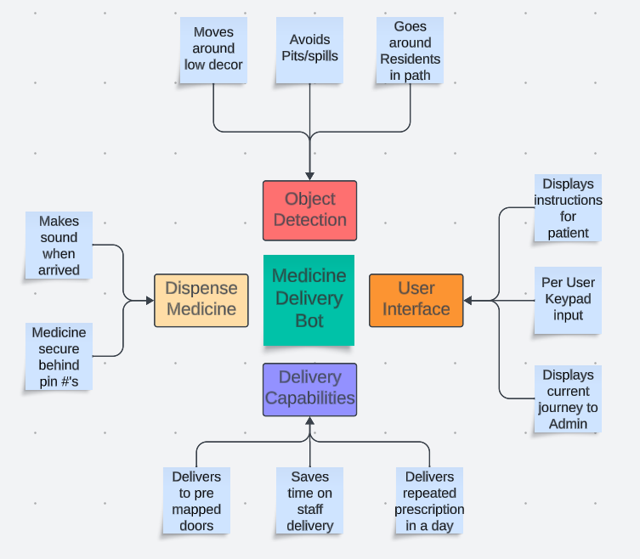

The Medicine Delivery Bot or MDB is to be deployed in independent or semi-independent wings of retirement facilities. The MDB will go through mapped-out facilities and deliver pre-packaged medications to each home in need at the direction of a human operator. The chosen array of IR, bump, and ping sensors help seamlessly move the MDB’s two independently driven wheels around the campus, and any unexpected obstacles. The MDB comes pre-mapped with the address of each resident to keep it on track and within the boundaries of the community.   
 The MDB comes with an easy-to-use user interface, while still keeping security in mind. The built-in LCD instructs the resident to use their security pin on the buttons on the board. Each step of the MDB’s journey will be sent back to the Admin to always be tracked for its driving to the delivery zone, status of objects obstructing it’s path, and the success of pin and medicine delivery.

**Technical-centered Sketch:**

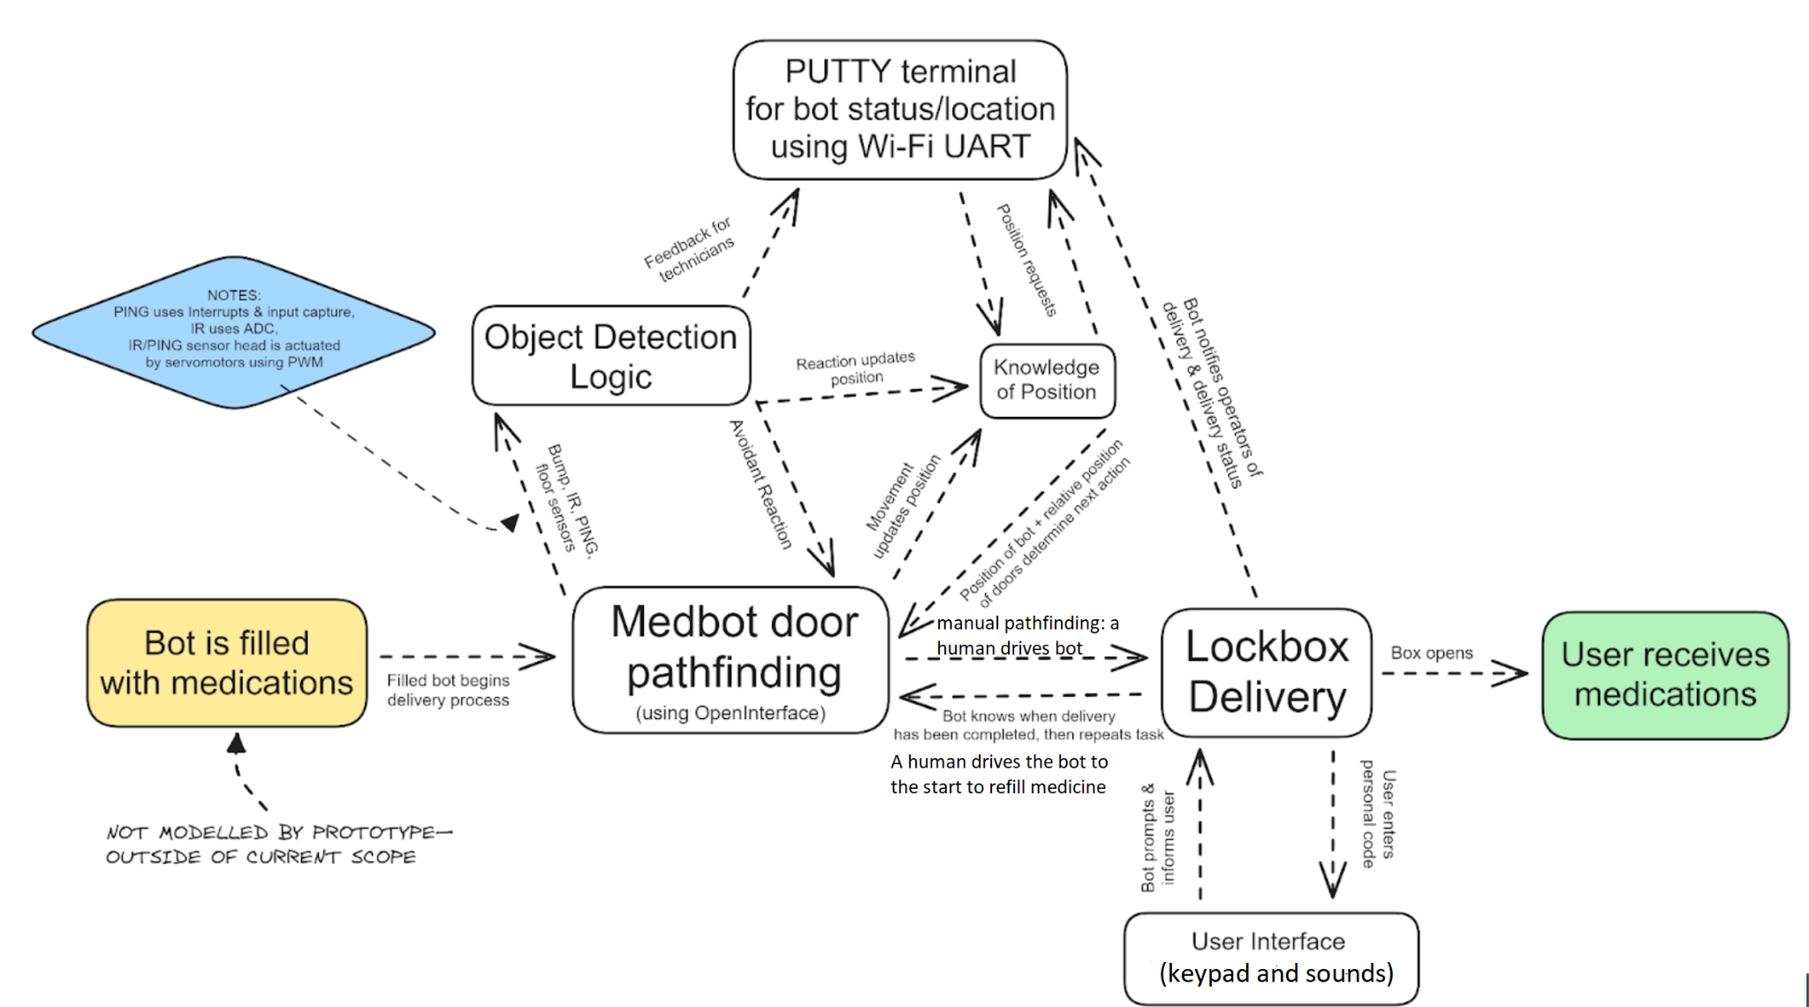

**Mapping Large Functional Requirements to the Platform Capabilities**

| **Base Capabilities Types** | **Default Usage** | **Project Usage** |
| --- | --- | --- |
| Open Interface | Robot Movement | Robot Movement, music |
| Interrupts | Ping Sensor | Ping Sensor |
| WiFi-UART | Cybot Communications | Cybot Communications |
| Analog to Digital Conversion | Infrared Sensor | IR Sensor |
| Input Capture | Ping Sensor | Ping Sensor |
| Pulse Wave Generation (PWM) | Servo Motor | Servo Motor |

**Test Field Sketch:**

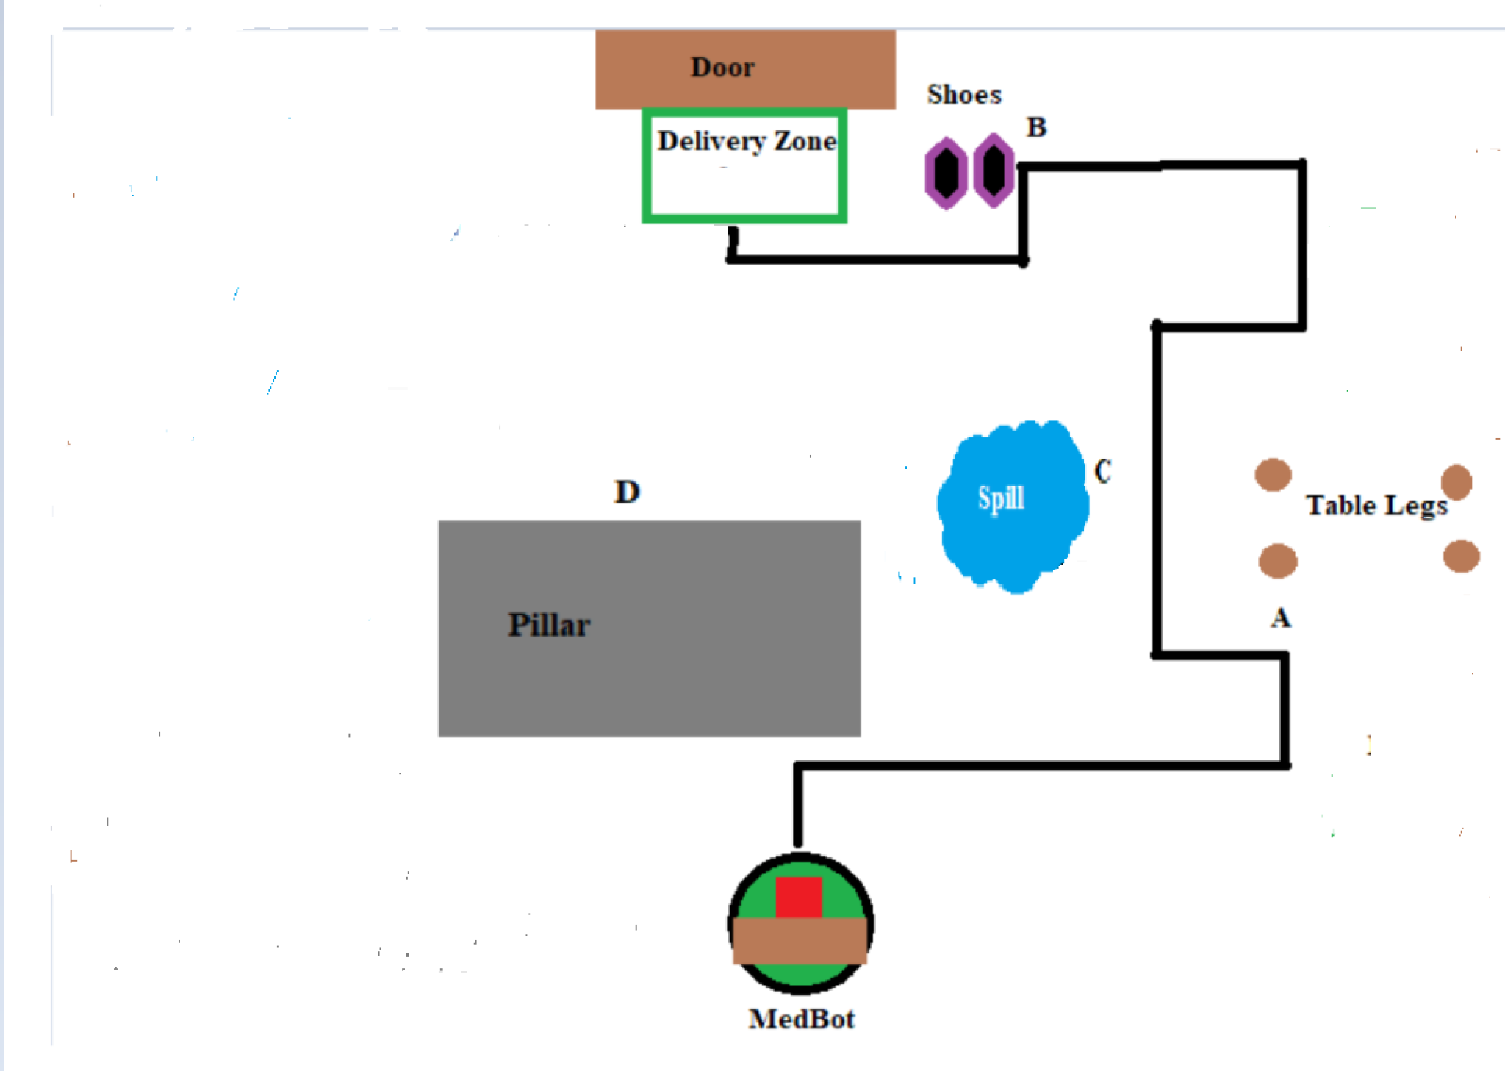

The following test field shows a common example of a corridor that the MDB must navigate to deliver to a resident’s room at a retirement community. The field works as a proof of concept for the MDB. There can be multiple delivery zone rooms for the MDB to deliver medicine to, but for a demonstration, only one delivery zone is shown.

The human operator starts the MDB by heading towards the delivery zone door, with a successful delivery. The MDB then observes a pillar at point D and the operator directs the MDB to steer clear to the right around the obstacle. Next, the operator controls the MDB to shuttle between a spill at point C and table legs at point A before turning left toward the destination. On its way to the door, the MDB evades the shoes at point B before arriving at the delivery zone by the operator’s control. After the medication gets dispensed, the MDB may return to the base starting position to refill or await further medication delivery times from the operator and nursing staff.

**Mapping Test Field Elements to Application Narrative**

| **Basic Test Field Objects and Other Elements** | **Description of how Test Field Elements Map to Application Narrative** |
| --- | --- |
| Tall wide objects | The MDB must avoid tall wide objects like bookshelves |
| Short objects | The MDB must avoid short objects like shoes |
| Pillars (tall thin objects) | The MDB must avoid tall thin objects like table legs |
| Holes | The MDB must avoid holes, i.e. spills |
| Out of bounds | The MDB must avoid going out of bounds of the retirement home facility |
| Destination zone | The MDB must reach pre-mapped delivery zone |

**Collaboration**

Madison Vosburg: The team gave Madison the responsibility of implementing button passwords, investigating how to make the MDB make sounds or play music when it arrives at the patient door, and PUTTY communication as part of the user interface of the MDB. She collaborated with Ryan Hillier on implementing and devising the coordinate and movement system.

Aydin Sesker: The team gave Aydin the responsibility of including functions outside of map functionality and user interface to allow the MDB to detect objects and move. Aydin will also work on the calibration of the MDB, which is essential for successful navigation.

Ryan Hillier: The team gave Ryan the responsibility of creating map functionality, coordinate system, and the base codebase, so the MDB knows its location and rotation at any point in time.

Ritwesh Kumar: The team gave Ritwesh the responsibility of finalizing the project proposal to help by doing work primarily outside of programming. In addition, he was responsible for writing out an elevator pitch to present at the beginning of our demo.

Contributions to the team process: The team contributed to the project as a whole by having open communication via text and Discord while working on the project. If there was a question on what a team member should work on, they contacted another team member or the group to see how they could contribute to the success of the project.

The whole team worked together on a rough draft of the project proposal. Madison and Ritwesh were originally responsible for creating the empathy map and POV statements. Aydin was in charge of the application story and creating the technical sketch. Ryan worked on the user and test field sketches, as well as the descriptions. Madison made the final edits to the completed project proposal.

Specifically for the POV statements, the whole team worked to find the user research sources used for the empathy map and in developing POV statements. Madison and Ritwesh originally were responsible for creating the empathy map. Once the empathy map was completed, several POV statements were written based on the user research the team had conducted. Madison formulated the final POV statement based on those.

**Sources:**

[1] “How many pills do your elderly patients take each day?,” HCP Live. <https://www.hcplive.com/view/how-many-pills-do-your-elderly-patients-take-each-day>. (accessed Nov. 1, 2023).

[2]“Relay Hospital Delivery Robot,” Swisslog Healthcare. <https://www.swisslog-healthcare.com/en-gb/products/transport/relay>. (Accessed Nov. 1, 2023).

[3] K. Trainum, R. Tunis, B. Xie, and E. Hauser, “Robots in Assisted Living Facilities: Scoping Review,” *JMIR Aging*, vol. 6, p. e42652, Mar. 2023, doi: <https://doi.org/10.2196/42652>.